**ASSIGNMENT-4**

|  |  |
| --- | --- |
| Date | 30 October 2022 |
| Team ID | PNT2022TMID02133 |
| Name | J Gokul |
| Student Roll Number | 2116190701050 |
| Maximum Marks | 2 Marks |

Problem Statement:

Write code and connections in wokwi for ultrasonic sensor. Whenever distance is less than 100 cm send "alert" to IBM cloud and display in device recent events.

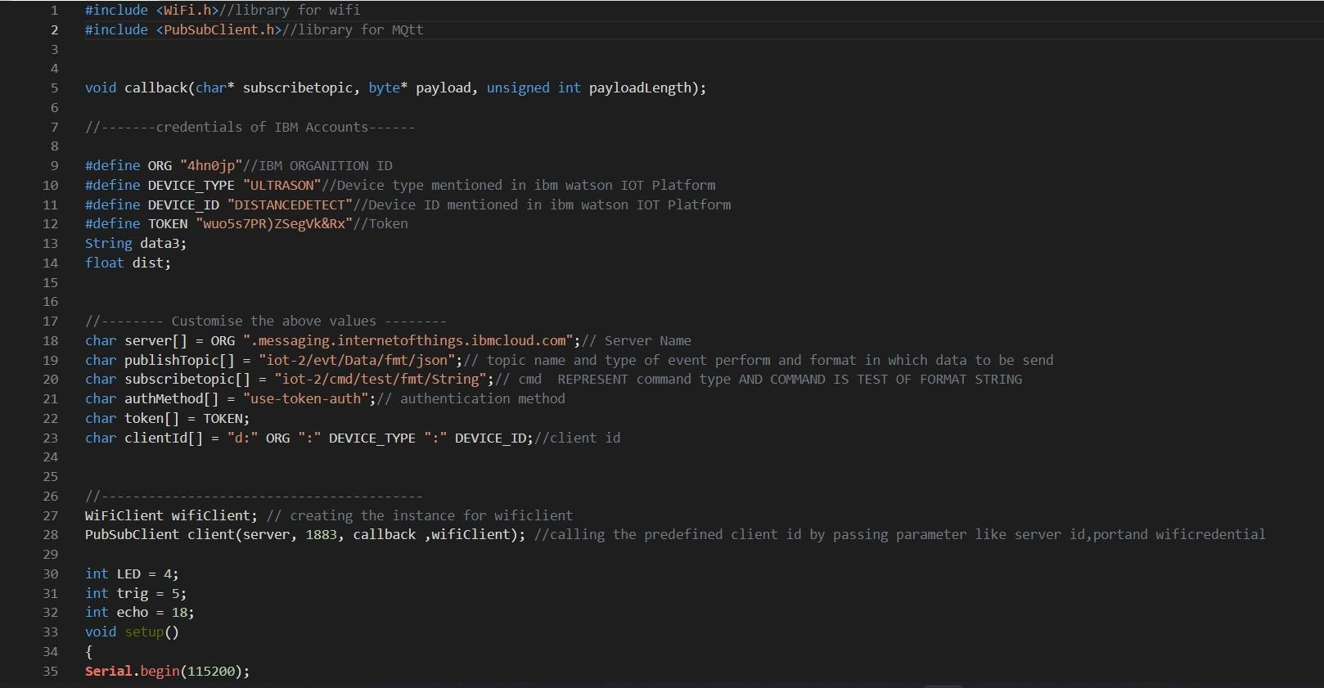CODE :

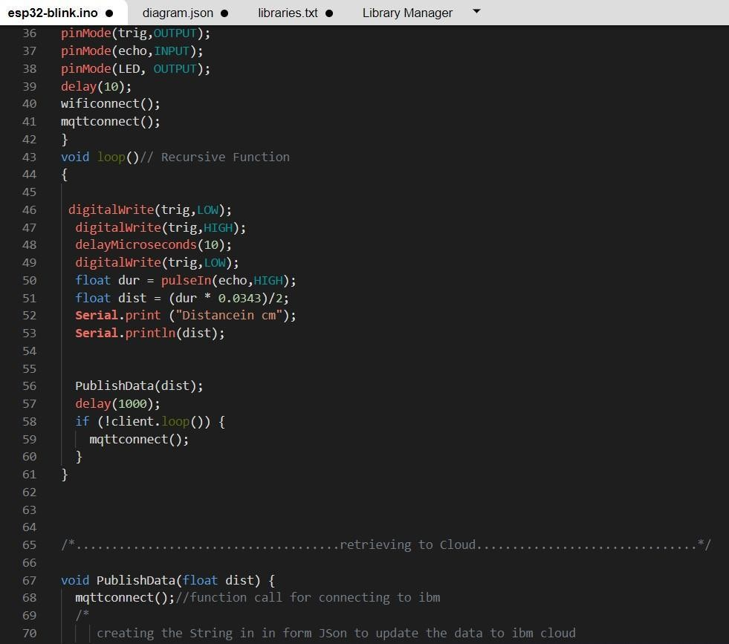

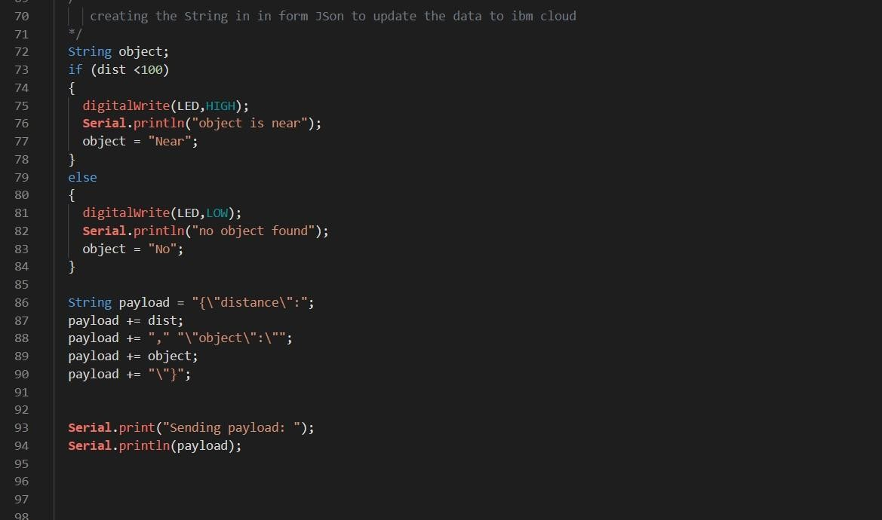

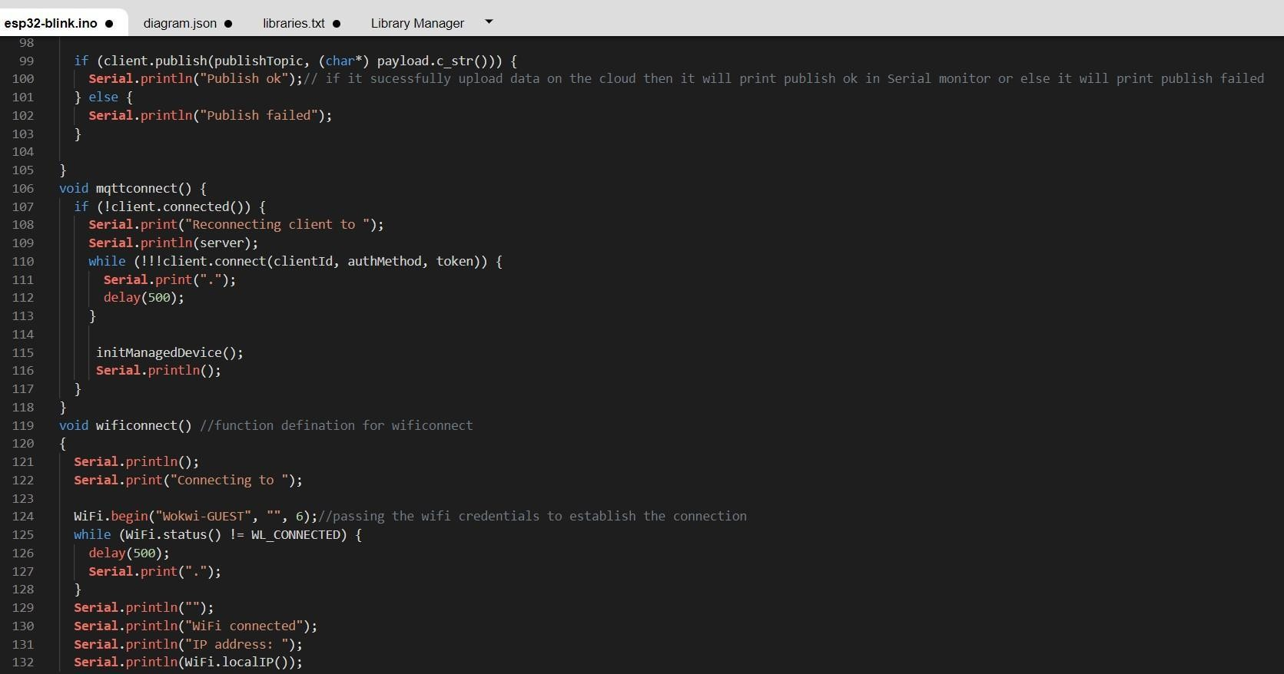

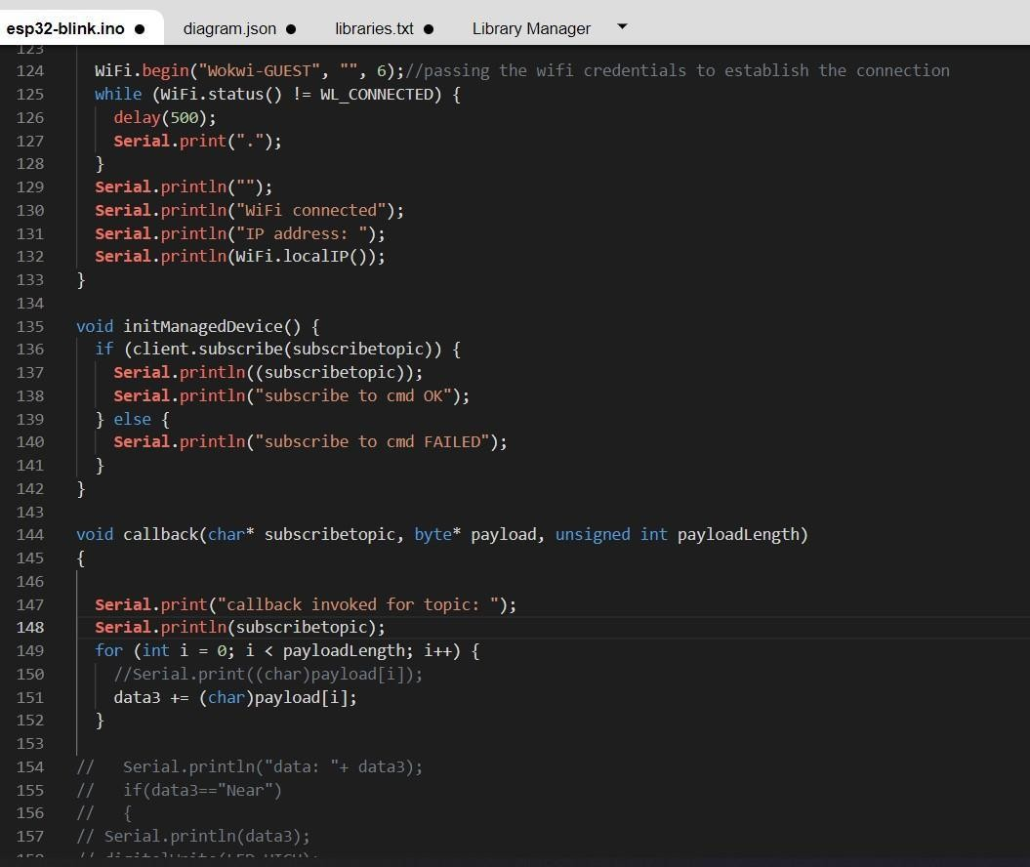

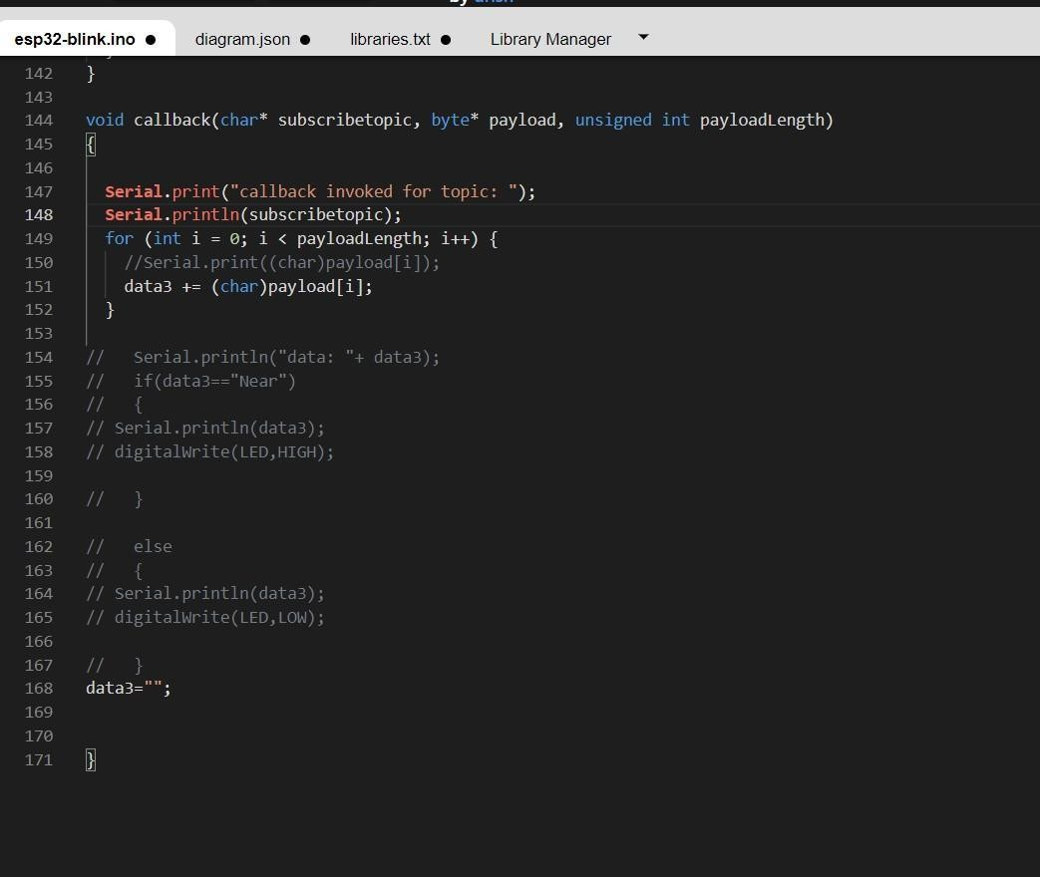

OUTPUT:

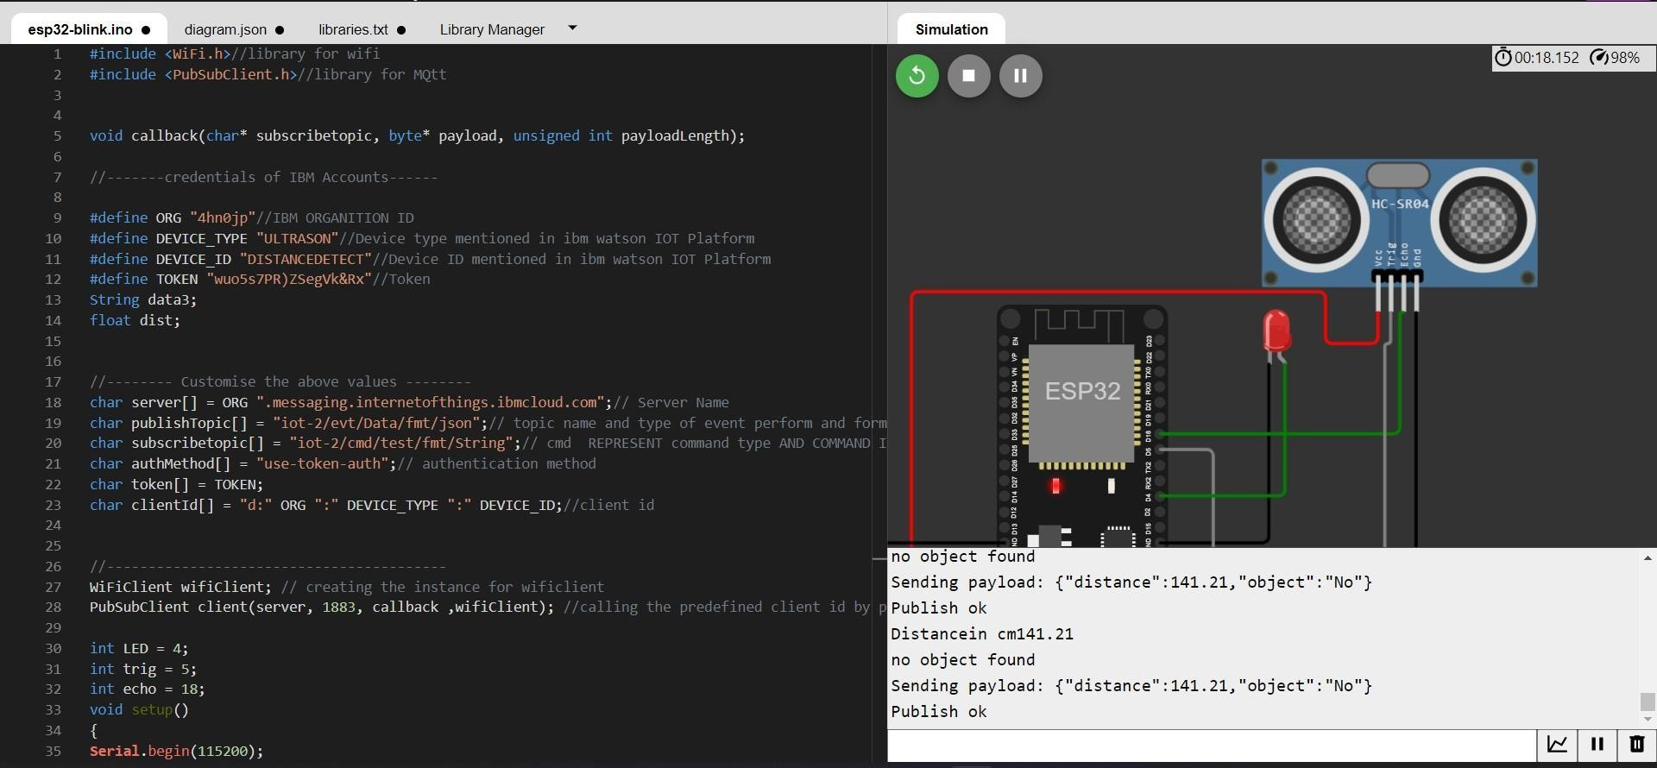

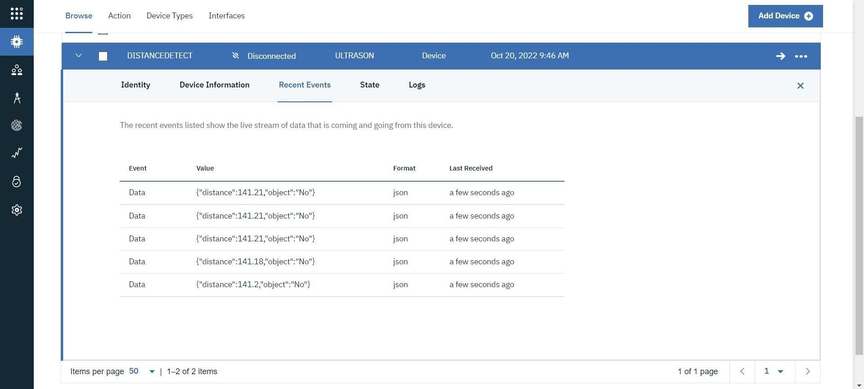Data send to the IBM cloud device when the object is far

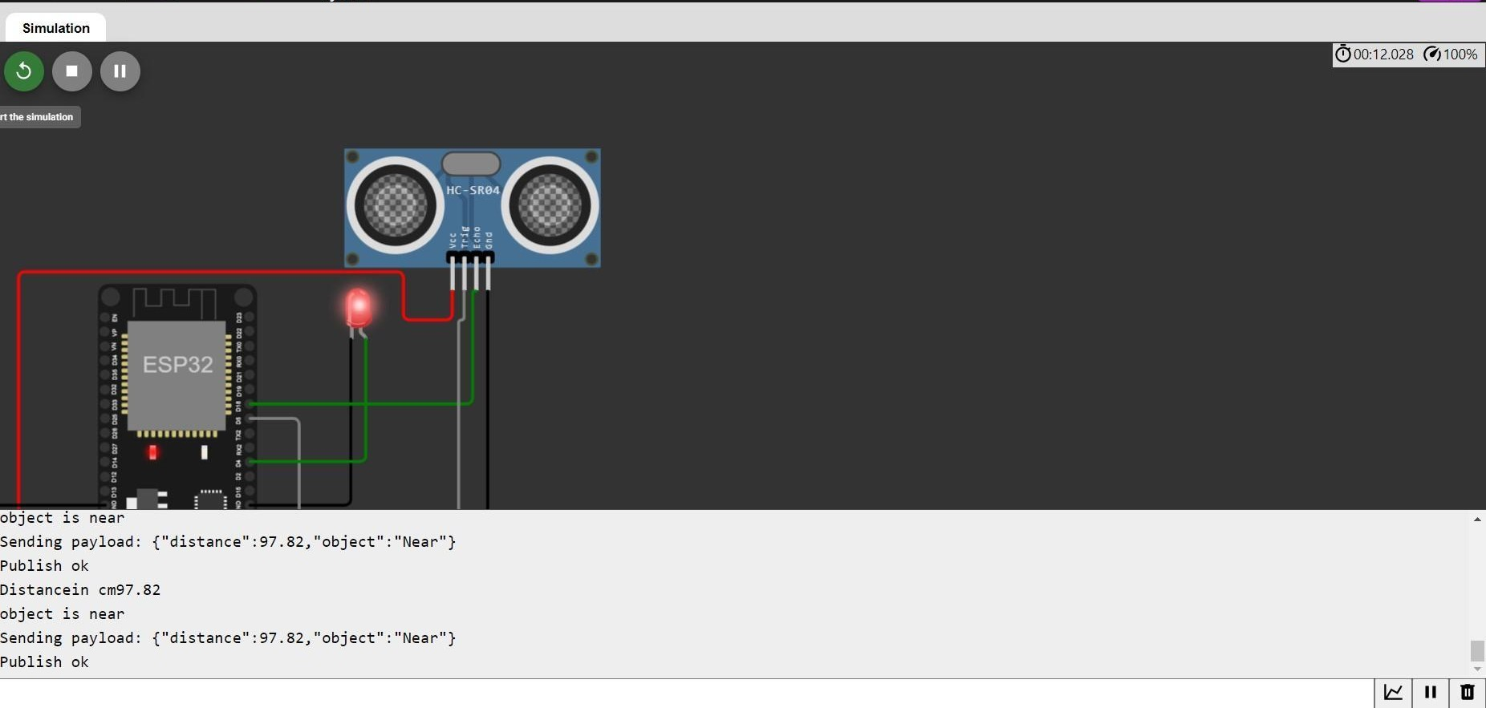when object is near to the ultrasonic sensor

Data sent to the IBM Cloud Device when the object is near

